along your spine to loosen tight muscles and restore natural range of motion (Only $1/minute).
Vibration Plate Therapy: A zero-effort exercise that burns calories, improves balance, and engages your nerves and muscles automatically. It is highly effective for patients managing neuropathy or looking for safer stability.
E-Stim & Heat Therapy: Gentle electrical impulses combined with professional, moist heat packs to instantly soothe, relax, and prep tight muscles before your treatment.
Your Next Steps to Vibrant Health
We carry a comprehensive, professional line of high-quality Supplements and NOW Essential Oils right in our office to support your wellness goals between visits. Let Dr. Waters recommend the exact products to maximize your results.

🎁 EXCLUSIVE NEW PATIENT OFFER
Ready to experience the Fountain Chiropractic difference? Mention this brochure when booking to unlock an exclusive introductory rate on your choice of HydroMassage, IST Table, or a Contour Light® Red Light consultation!

📅 Book Your Session Today!
Our schedule fills up quickly. Scan the QR code below, visit our website, or speak directly with our front desk team right now to secure your appointment.
- Call/Text Us: (719) 799-6555
- Stop By: 468 N. Santa Fe Ave., Fountain, CO 80817
Explore More & Book Online:www.fountainchiropractor.com
Fountain Chiropractic & Wellness Center: Lighting the way to holistic wellness!!
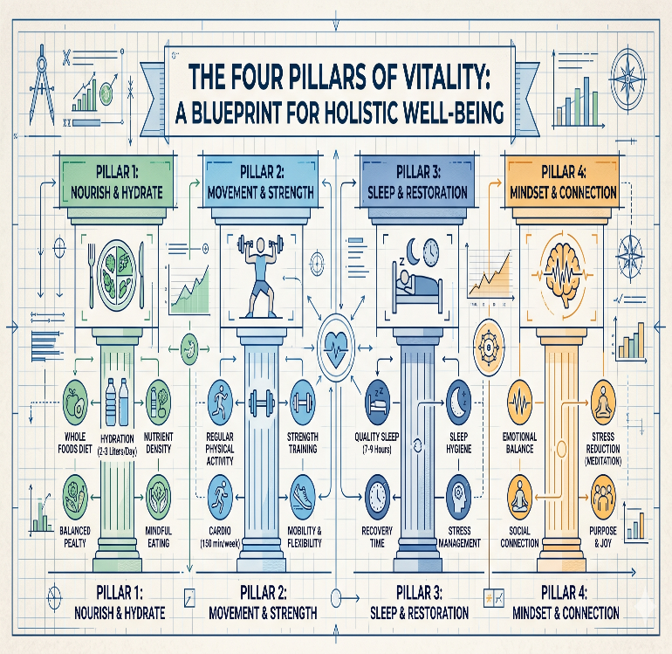
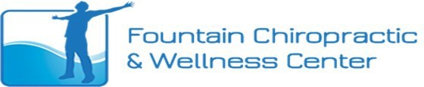
Fountain Chiropractic & Wellness Center 468 N. Santa Fe Ave., Fountain, CO 80817 (719) 799-6555
www.fountainchiropractor.com
Welcome to our practice!
Your Journey to Lasting Health and Vitality Starts Here!!
Stop just managing your symptoms.
Discover advanced, holistic therapies designed to heal your body from the inside out.
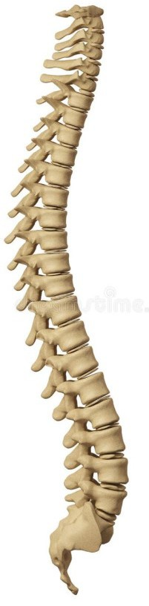
Our oﬃce has numerous therapies available to provide holistic care for a wide variety of needs. Turn the page to unlock your personalized path to wellness—and claim your introductory session!
Chiropractic
Massage & HydroMassage Ozone & Oxygen Therapy Red Light Therapy
Weight Loss
Heat Therapy Vibration
Electrical Stimulation (E-Stim) Intersegmental Traction (IST Table)
Sensitivity Elimination
Functional Medicine
Supplements & Oils

Welcome to Your Complete Wellness Hub!
At Fountain Chiropractic & Wellness Center, we don’t believe in a one-size-fits-all approach to healthcare. Our office features an array of cutting-edge, advanced therapies designed to provide comprehensive, holistic care tailored strictly to your unique lifestyle and goals.
Whether you are looking to eliminate chronic pain, supercharge your daily energy, recover from an injury, or completely revitalize your metabolic health, Dr. Waters and our dedicated team are here to guide you every step of the way.
Ready to feel like yourself again? Turn the page to see how our targeted therapies can transform your life.

FOUNDATIONAL CARE & ADVANCED WELLNESS

Chiropractic Care & Functional Medicine

Structural Alignment: Dr. Waters helps restore natural motion and precise alignment to your spine, directly reducing nerve interference so your entire body can function at its absolute peak. Every single visit is completely personalized to support your natural healing capacity.

True Functional Medicine: We look at the whole person, not just isolated symptoms. If you are struggling with Thyroid Dysfunction, GI Issues, Hormone Imbalances, or Chronic

Autoimmune Disorders, we dig deep to find the root cause. Your journey begins with an in-depth 60-90 minute consultation, a comprehensive blood analysis, sensitivity testing, and a toxic evaluation to build your custom treatment map.

🌬️ Advanced Oxygen & Ozone Detoxification

Ozone Steam Sauna: Cleanse your lymphatic tissue of deep-seated toxins effortlessly. Our specialized steam sauna opens your pores, allowing therapeutic ozone to penetrate the skin and reach your bloodstream, fat, and lymph tissues. It is an incredible defense protocol for those dealing with arthritis, disc pain, stress, or immune deficiencies.

Supplemental Oxygen Therapy: Boost your baseline cellular energy and accelerate systemic healing. Enjoy an oxygen session right in our waiting room, or pair it seamlessly with a HydroMassage session for ultimate relaxation.

⚡ RECOVERY, PAIN RELIEF & CONTOURING
👙 Contour Light® Red Light Therapy
Discover a revolutionary, non-invasive, FDA-cleared approach to total body transformation.
Effortless Body Contouring: Target stubborn fat cells in your hips, waist, and thighs. Clinical studies show an average loss of over 3.3 inches in just six sessions!
NASA-Researched Pain Relief: Originally researched by NASA, near-infrared light penetrates deep into tissues to radically improve local circulation, ease muscle stiffness, and melt away joint pain.

Skin Rejuvenation: Naturally stimulates collagen to smooth out wrinkles, scars, and stretch marks.
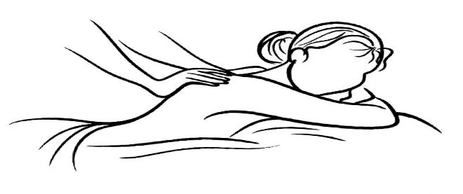
💆 Hands-On Muscle Therapy
Targeted Massage Therapy: Our licensed therapist works directly alongside Dr. Waters to ease stubborn muscle tension and boost localized circulation. Pro Tip: Schedule your massage right before your adjustment to perfectly prime your body.
HydroMassage Bed: Short on time but need a quick fix? For just $1 a minute, enjoy warm water jets through a waterproof surface to instantly decrease tension and improve blood flow.
🛠️ Passive Therapy & Recovery Accelerators
Intersegmental Traction (IST Table): This feels absolutely amazing right after an adjustment! Rhythmic rollers gently travel

